We know that dementia can knock your confidence. This can make it very difficult to join a group. We want you to know that we are a friendly and supportive group who welcome new members. We would be very interested in hearing from you if you might like to be part of our group.
Please contact
Jo Scarle (Young Onset Dementia Development Officer) or Rachael Hodgetts (Administrator) on 01562 828894 or email rachael.hodgetts@hacw.nhs.uk

We may be able to help with transport. Please let us know if you would like to discuss this.
We are part of the Dementia Engagement and Empowerment Network (DEEP). To find out more about this network please contact Rachael Litherland at www.dementiavoices.org.uk or ring 01392420076

Dementia Voice (Worcestershire)
A group for people who are living with dementia at a Younger Age

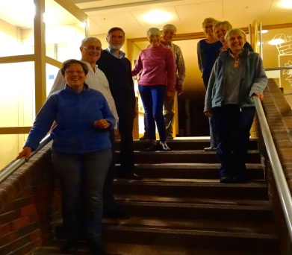

We are an activist / advocacy group of younger people living with dementia, family members and supporters

We meet once every 3 months from 7.00pm to 9.00pm

Venue;
Bromsgrove Room
County Hall
Spetchley Road
Worcester
WR5 2NP
(Near the Worcestershire Woods Country Park)

Who are we?
We are a friendly and supportive group who have been meeting since May 2014. We want others to recognise that we are still people who need to get out and do things. We want our opinions to matter.
Our aim is to bring about change in Worcestershire in the services and support that is offered to younger people with dementia and their families. We have been involved in;
- Creating a more positive image of people living with young onset dementia through presentations, the development of a website and through our individual contacts with others
- Influencing the development of services for younger people
- Fighting bureaucracy
- Representing the views of people who are less able to express their own perspectives

How do we do this?
We split into smaller groups when we meet, for people living with dementia and for family members and supporters. We do this because we think it’s important for everyone to feel free to say what they want to, and we recognise that people don’t always feel comfortable to talk openly in front of their relatives.

We support each other to discuss our concerns and share experiences. We learn from each other through sharing the good and the bad, successes and problems. We also exchange information and try to stop the ‘learning by default’ that often happens.

We work with others to influence their work through teaching, meetings and personal contact.

We feel empowered and energised by the work we do.

